Operation & Management of Mali, Liberia and DRC Service Center April 26, 2022

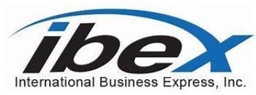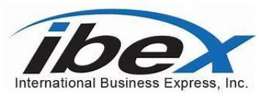

**National institute of Health (NIH)**

**Source Sought Synopsis**

**SUBMITTED TO:**

**Government POC**

**Due: April 26, 2022, by 2 pm EST**

**SUBMITTED BY:**

**7826 Eastern Ave, NW Suite 211 Washington, DC 20012 DUNS Number 093560626**

[**www.ibexusa.com**](http://www.ibexusa.com/)

Ronda Kane - Ronda Kane Authorized RepresentativePage-1

Use or disclosure of proposal data is subject to the restriction.

DFC Content Manager Gap Analysis Support Services March 18, 2022

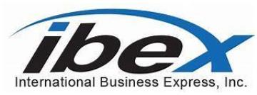

26 April 202292

Ms. Kristel Ruch

cc Gabriel Contreras

National Institute of Health (NIAD)

5601 Fisher Lane, Suite 3D11

Bethesda, MD 20892 USA

Re: Operation and of the Mali of Service Center, Liberia Service Center and Democratic

Republic of Congo Service Center

Dear Ms. Rush:

The IBEX team is pleased to submit our enclosed sources sought market research technicalsolution to the Development Finance Corporation for the Content Manager Systems IntegrationSupport Market Research request. As an innovative information and communications technologycompany, we are excited by the opportunity to work together and partner with the DevelopmentFinance Corporation (DFC), Office of Administration (OA) Records and Information Management(RIM) Team.

In support of this market research request, we have assembled a team of subject matter expertswith Federal Government, Department of Defense, Department of Commerce, and Industryexperience. Our experts are well versed in content management, records management,information technology, physical and cybersecurity, business systems, software, systemintegration, and O&M operations.

Our team brings decades of hands-on experience, capacity, and modernization in O&M andcontent management operations. Together, we possess the skills, knowledge, expertise, andability to successfully partner with DFC, OA, and RIM in fulfilling its mission goals and objectivesand delivering the best possible content manager systems integration and O&M support solution.IBEX is a Small Disadvantaged Business, GSA Schedules i.e., STARS 3 GWAC, HUBZonecertification.

If selected, we are ready to be your trusted partner, ready to take operational responsibility underthe direction and guidance of the DFC, OA, RIM Contracting Officer, and ready to provideinnovative ideas and leading-edge content management solutions.

Based on our past history with the Government, Defense, and Industry, we are ready to executekey start-up activities outlined in our phased approach solution(s) and roadmap from day one.We plan to hit the ground running and leverage our experience to make the DFC contentManager System Integration operation the gold standard in the government.

Should you have questions and require further information regarding our companyand/or our RFI submission, please don’t hesitate to contact me at telephone (202) 726-8761 or via mail at rkane@ibexusa.com. We would be delighted to entertain an in-person meeting/briefing.

Sincerely,Ronda Kane, IBEX

Director of Government Solutions

Page-2

Use or disclosure of proposal data is subject to the restriction.

Mali, Liberia, DRC Service Center March 18, 2022

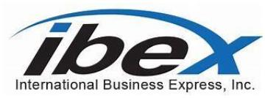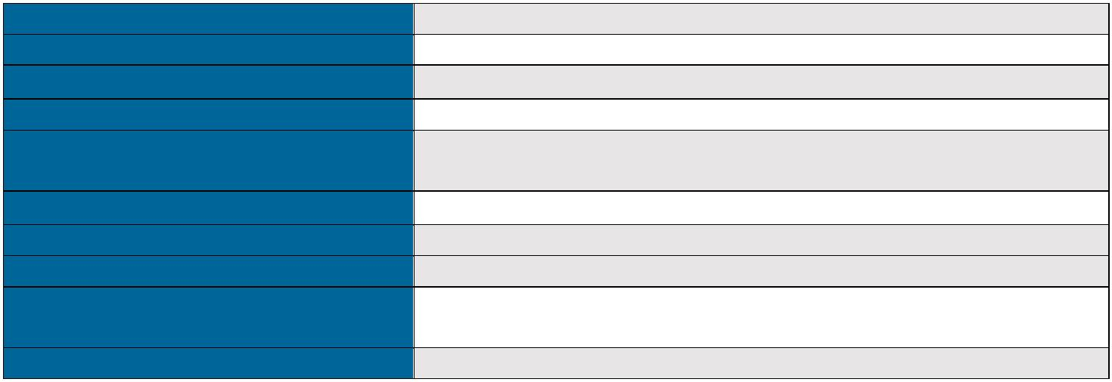

**INTRODUCTION**

*International Business Express, Inc. (IBEX) is pleased to submit a response to the NIADMali, Liberia and DRC Service Center Source Sought Notice. IBEX is a fast growing,* ***Small Disadvantaged and Minority,Owned Small Business*** *company that provides a wide spectrum of Operation and Maintenance technicalsolutions and expertise in processes, people, operations, policy and application development.*

**COMPANY PROFILE**

**Company Name** International Business Express, Inc.**Company Address** 7826 Eastern Avenue, NW **Corporate Email Address** rkane@ibexusa.com

**Telephone Number/FAX Number** Ph: 202-726-8761 Ext. 103/ Fax 202-726-9070**Corporate POC** Ronda Kane, Director of Government Solutions

**Website Address** www.ibexusa.com

**DUNS Number** 093560626 **Employer Identification Number** 522033466

**Size Standard (NAICS 541512)** Small Disadvantaged, Small Minority Disadvantaged

Business, HUBZone Certified **GSA Schedule Number** GS-06F-0775Z

**Capabilities:** The IBEX team has a cadre of highly skilled professionals from the federalgovernment, defense, and industry who possess masters and bachelor’s degrees, andgovernment, and industry certifications in information technology, system engineering, cybersecurity, computer science, information management systems, software engineering, analytics,business management operations, and program management.

Expertise includes Content Management, Application Development/Management, CloudComputing, Virtualization, Information Technology, Network Engineering, Infrastructure,Cybersecurity, System Integration, and Business Operations.

**Content Manager Tools, Applications, & Software (CMS):** Micro Focus (Content Manager),Oracle, Drupal, Adobe (Magento), WordPress, Contentstack, HubSpot, DocStar EMC. Core CMapplications and platforms include MS Office 365, Oracle, Salesforce (Insight & supportingmodules), Bullhorn, JobDiva, Thryv, Share Point, and Suralink.

**DFC SOO Capabilities:** The IBEX team professionals understand and are experienced withMicro Focus CM software and other CM software applications and protocols working with theDepartment of Commerce, Department of Defense, Government System Integrators, and Fortune500 companies.

Team IBEX has experience in managing mission critical electronic files, content, data, sensitivedocuments, and archiving operations adhering to the National Archives and RecordsAdministration content management protocol and best practices.

Page-3

Use or disclosure of proposal data is subject to the restriction.

DFC Content Manager Gap Analysis Support Services March 18, 2022

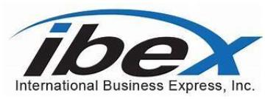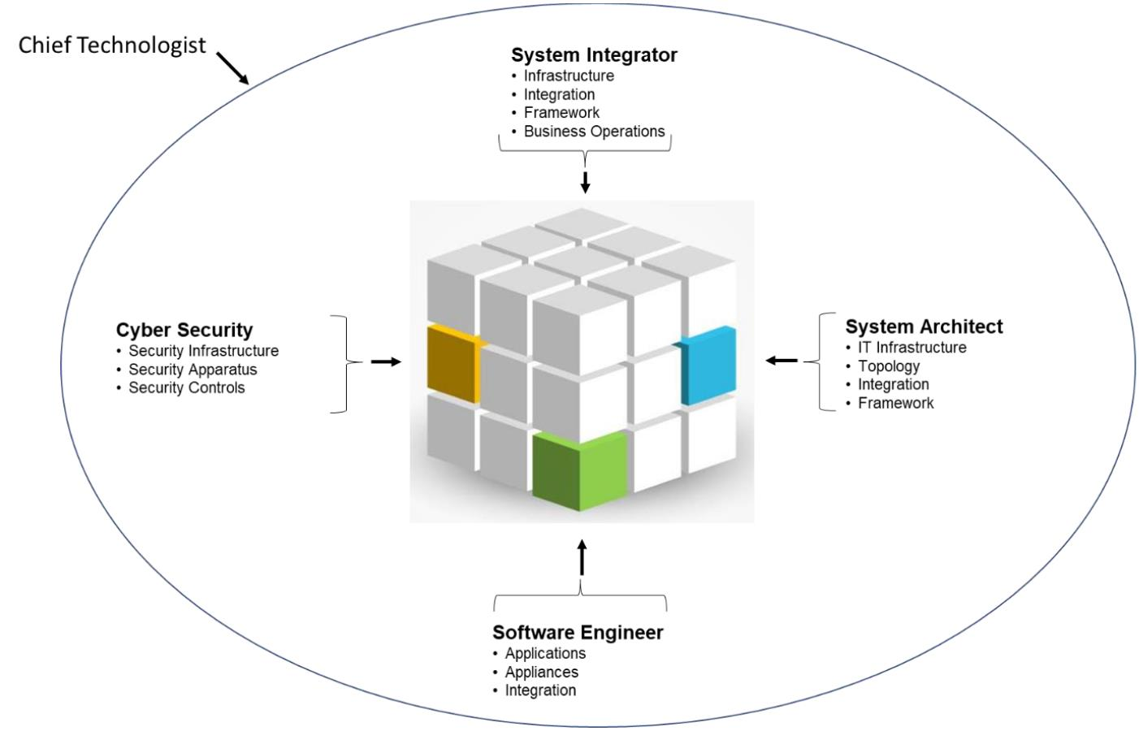

**IBEX Team Market Research Technical Solution CM Gap Analysis**

**Concept of Operations:** Our Chief Technologist will conduct a detailed gap analysis ofthe current content manager by conducting a holistic analysis of the entire process. Theprocess will be broken out into several elements which will be identified as cubes. Cubeswill be parsed out to “System Analyst”, i.e., IT, System Engineers, System Architects,Cybersecurity, and System Integrators. The “System Analyst” will conduct the gapassessment in their respective cubes.

The Chief Technologist will interview stakeholders, study the current business process,review the software applications, platforms, IT, and business operations with Micro Focusand the Contracting Officer Representative (COR) and Technical Contracting Officer(TCO) to fully comprehend the current CM process and understand DFC’s end statemission goals and objectives.

Afterwards, the Chief Technologist will discuss the findings and analysis with the “SystemAnalyst.” The Chief Technologist will compare the current state to the future state (“As-Is/ To-Be) and make recommendations based on process improvements, security,business processes, application business rules identified by the IBEX team.

**Deliverables:** After initial discussion with the DFC COR and TCO, the Chief Technologistwill provide the following deliverables. Detailed analysis, findings, and recommendationsreport, process improvement remediation plan, and road map.

Page-4

Use or disclosure of proposal data is subject to the restriction.

DFC Content Manager Gap Analysis Support Services March 18, 2022

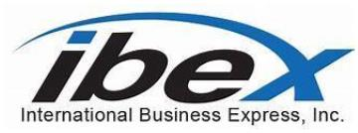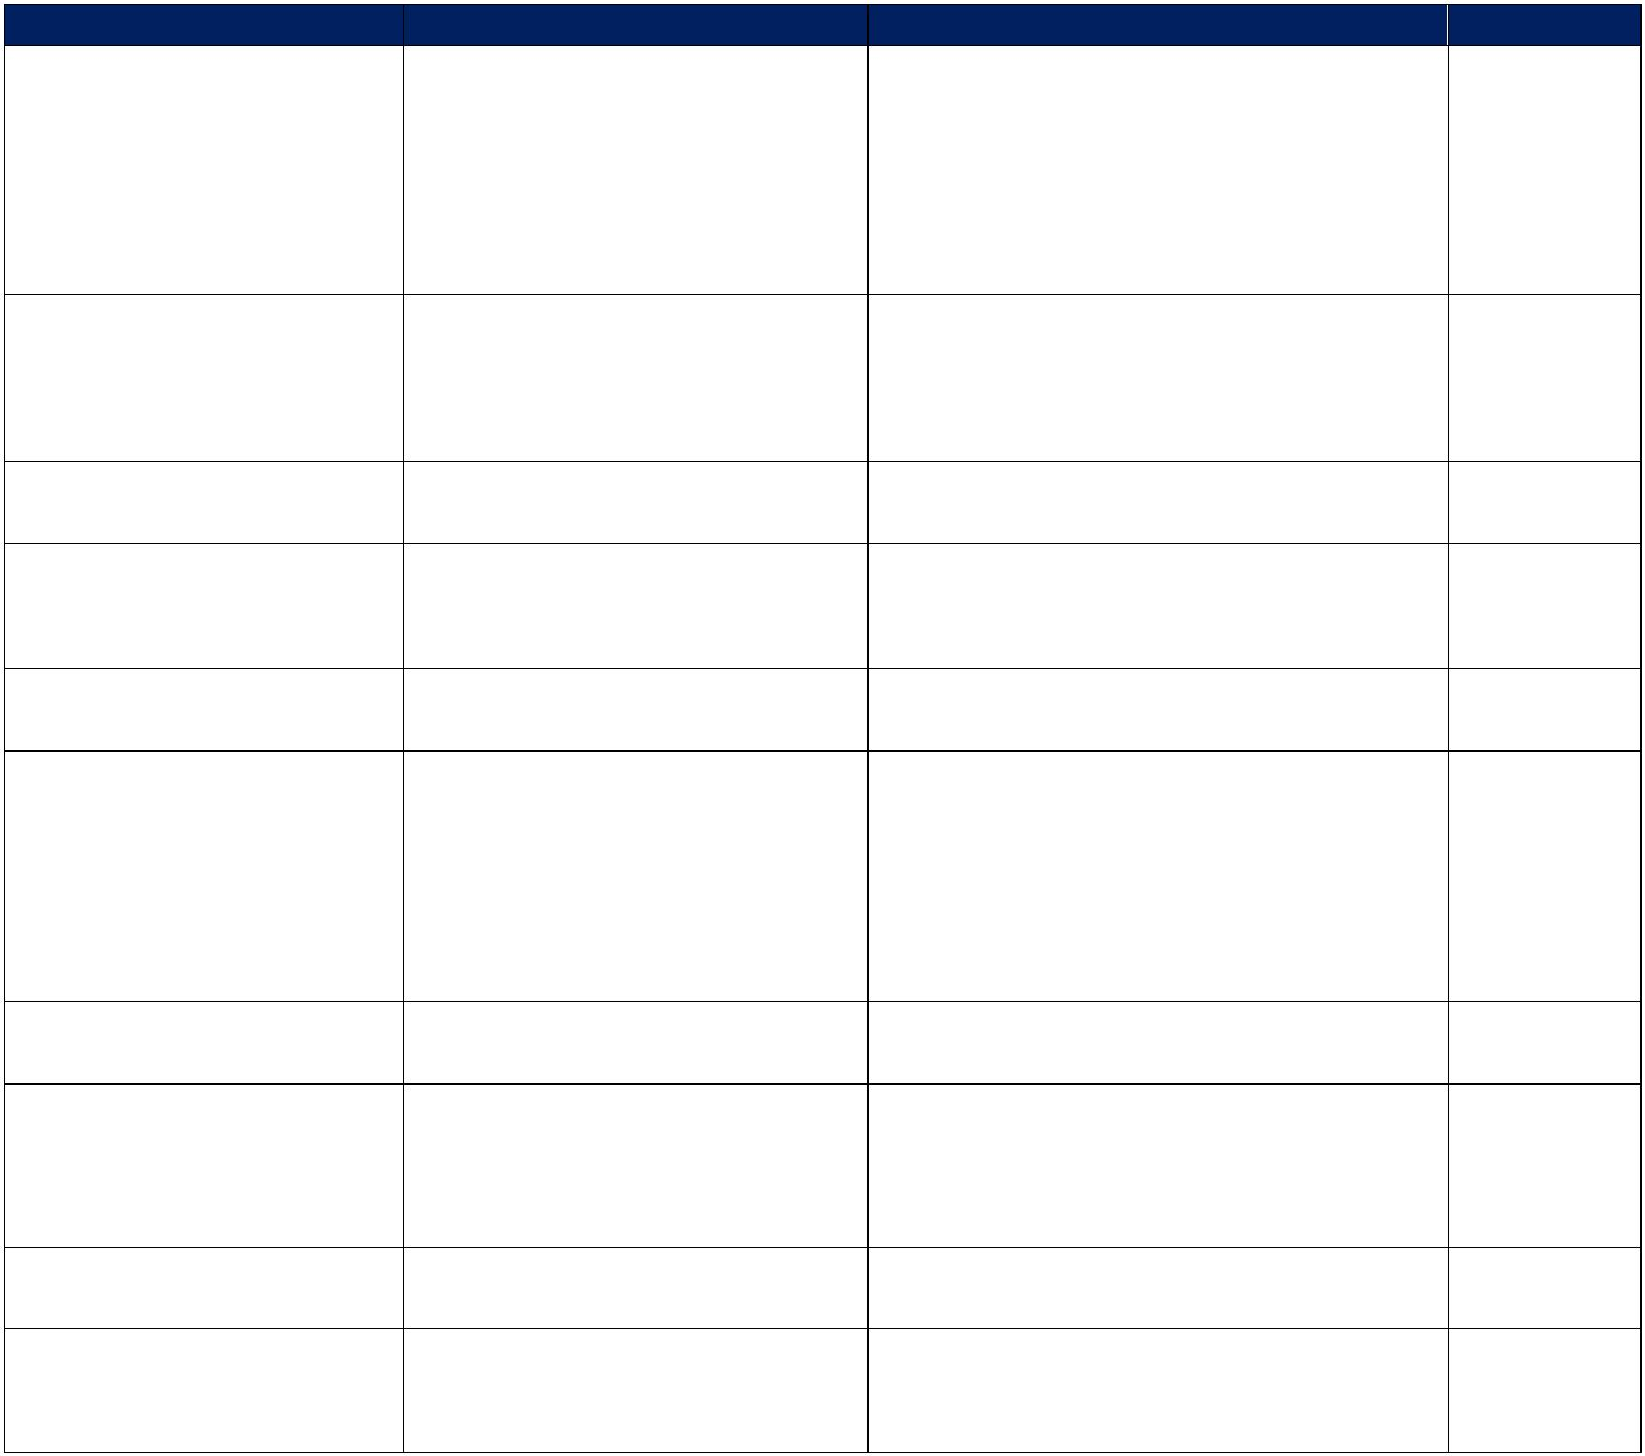

**CM Gap Analysis Integrated Project Plan:** Led by Chief Technologist

Phases (P) Activity Deliverables Duration P1: Discovery Discover: • Statement of Work 1 Wks.

• System Discovery • Concept of Operations • Business Process • Integrated Project Plan • Interview

• Questionnaire • As-Is/To-Be

P2: Planning Plan: • Resource List 1 Wks.

• Resources • Cost Proposal • Tools

• Applications

P3: Kickoff Develop: • Kickoff Presentation 24 Hrs. • Presentation

P4: Gap Assessment Conduct: • Gap Assessment Report 5 Wks. • Gap Assessment • Traceability Matrix Report • Traceability Matrix

P5: Analysis Conduct: • Analysis Report 1 Wks. • Analysis

P6: Reporting Develop: • Analysis Report 1 Wks. • Analysis • Finding Report

• Finding • Recommendations Report• Recommendation • Remediation Report• Remediation • Roadmap

• Roadmap

P7: Out brief Out brief: • Out brief Presentation 24 Hrs. • Out brief Presentation

P8: Process Develop: • Present Process Improvement 1 Wks. Improvement • Process Improvement Plan

Plan

• Verification & Validation

P9: O&M Develop: • Present O&M Concept of Ops 5 Days.

O&M Concept of Operation

P10: Patch & Releases Maintenance: • Per COR request TBD

• Patches

• Upgrades

Page-5

Use or disclosure of proposal data is subject to the restriction.